**Web Based Application Development – Tutorial**

**Exercise 01**



Styles.css

body {

margin: 0;

padding: 0;

font-family: Arial, sans-serif;

background-image: url(Back.jpg);

background-size: cover;

background-position: center;

}

.container {

display: flex;

flex-direction: column;

justify-content: flex-start;

align-items: center;

height: 100vh;

}

h1 {

display: flex;

justify-content: flex-start;

font-size: 36px;

text-align: center;

margin-bottom: 20px;

color: #ff0000;

}

.quote-box {

display: flex;

flex-direction: column;

justify-content: center;

background-color: rgba(255, 255, 255, 0.5);

padding: 20px;

max-width: 500px;

height: 300px;

}

.quote {

color: #4153ad;

font-size: 24px;

text-align: center;

}

small {

text-align: right;

}

<!DOCTYPE html>

<html>

<head>

<title>Ex 2</title>

<link rel="stylesheet" href="styles.css" />

</head>

<body>

<div class="container">

<h1>Quotes for Life</h1>

<div class="quote-box">

<p class="quote">

“You were born to be a player. You were meant to be here. This moment

is yours.”

</p>

<small>―Herb Brooks</small>

</div>

</div>

</body>

</html>

**Exercise 02**

Create the following web page using html & CSS

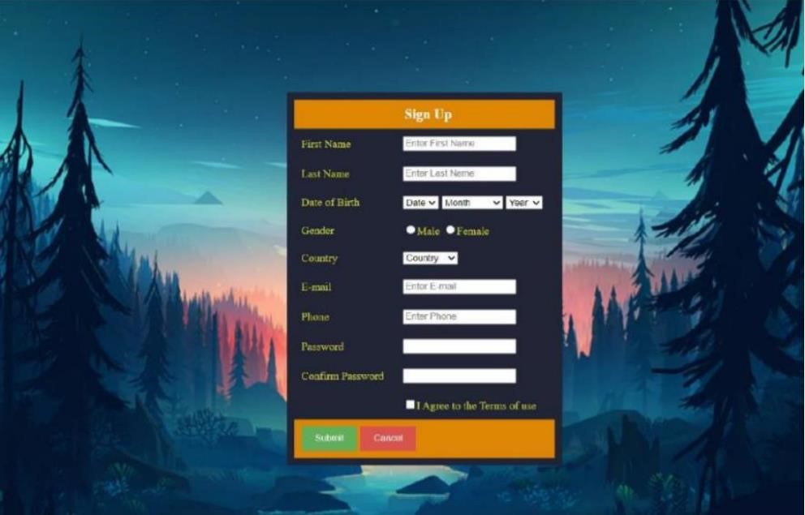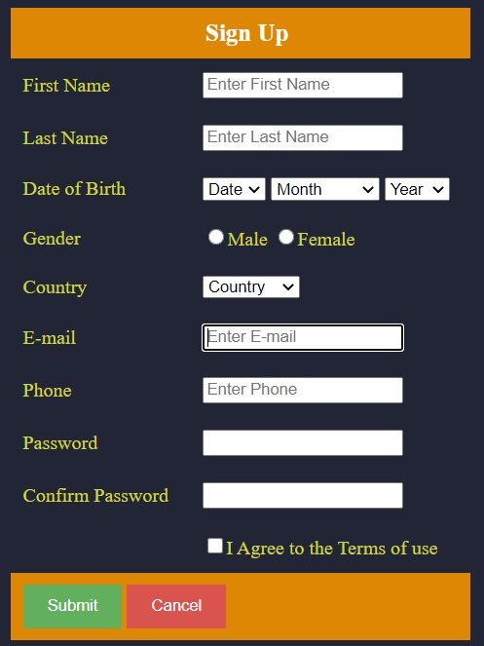

<!DOCTYPE html>

<html>

<head>

<title>Assignment css</title>

<style>

body {

margin: 0;

padding: 0;

font-family: Arial, sans-serif;

background-image: url("Back.jpg");

background-size: cover;

background-position: center;

}

.container {

display: flex;

flex-direction: column;

justify-content: center;

align-items: center;

height: 100vh;

}

form {

background: #222536;

}

table th {

color: #fff;

background: #de8704;

}

table th,

table td {

padding: 12px;

margin: 5px;

}

table td label {

color: #fffb00;

}

table .bottom {

background: #de8704;

}

table tr td input[type="submit"] {

background: #088608;

border: none;

color: #fff;

padding: 15px;

cursor: pointer;

}

table tr td input[type="reset"] {

padding: 15px;

color: #fff;

background: #cc145d;

border: none;

cursor: pointer;

}

</style>

</head>

<body>

<div class="container">

<form onsubmit="return validateForm()">

<table>

<tr>

<th colspan="3">Sign up</th>

</tr>

<tr>

<td><label for="ownerName">First Name</label></td>

<td>

<input

type="text"

id="ownerName"

name="ownerName"

placeholder="Enter First Name"

required

/>

</td>

</tr>

<tr>

<td><label for="email">Last Name</label></td>

<td>

<input

type="email"

id="email"

name="email"

placeholder="Enter Last Name"

required

/>

</td>

</tr>

<tr>

<td><label for="phoneNumber">Date of Birth</label></td>

<td>

<select id="day" name="day" required>

<option value="">Date</option>

<option value="1">1</option>

<option value="2">2</option>

<option value="3">3</option>

<option value="4">4</option>

</select>

<select id="month" name="month" required>

<option value="">Month</option>

<option value="January">January</option>

<option value="February">February</option>

<option value="March">March</option>

</select>

<select id="year" name="year" required>

<option value="">Year</option>

<option value="2023">2023</option>

<option value="2022">2022</option>

<option value="2021">2021</option>

</select>

</td>

</tr>

<tr>

<td><label>Gender</label></td>

<td>

<input

type="radio"

id="male"

name="gender"

value="male"

required

/><label for="male">Male</label>

<input

type="radio"

id="female"

name="gender"

value="female"

required

/><label for="female">Female</label><br />

</td>

</tr>

<tr>

<td><label for="country">Country</label></td>

<td>

<select id="country" name="country" required>

<option value="Sri Lanka">Sri Lanka</option>

<option value="USA">USA</option>

<option value="Canada">Canada</option>

<option value="UK">UK</option>

</select>

</td>

</tr>

<tr>

<td><label for="emailInput">Email</label></td>

<td>

<input

type="email"

id="emailInput"

name="emailInput"

placeholder="Enter Email"

required

/>

</td>

</tr>

<tr>

<td><label for="phoneNumberInput">Phone</label></td>

<td>

<input

type="text"

id="phoneNumberInput"

name="phoneNumberInput"

placeholder="Enter Phone"

required

/>

</td>

</tr>

<tr>

<td><label for="passwordInput">Password</label></td>

<td>

<input

type="password"

id="passwordInput"

name="passwordInput"

required

/>

</td>

</tr>

<tr>

<td><label for="confirmPasswordInput">Confirm Password</label></td>

<td>

<input

type="password"

id="confirmPasswordInput"

name="confirmPasswordInput"

required

/>

</td>

</tr>

<tr>

<td></td>

<td>

<input type="checkbox" id="termsCheckbox" value="text" required />

<label for="termsCheckbox">I agree to the terms of use</label>

</td>

</tr>

<tr>

<td class="bottom" colspan="2">

<input type="submit" />

<input type="reset" />

</td>

</tr>

</table>

</form>

</div>

</body>

</html>